**Assignment 8 – Small Multiples in Tableau**

Q1)

Q2)

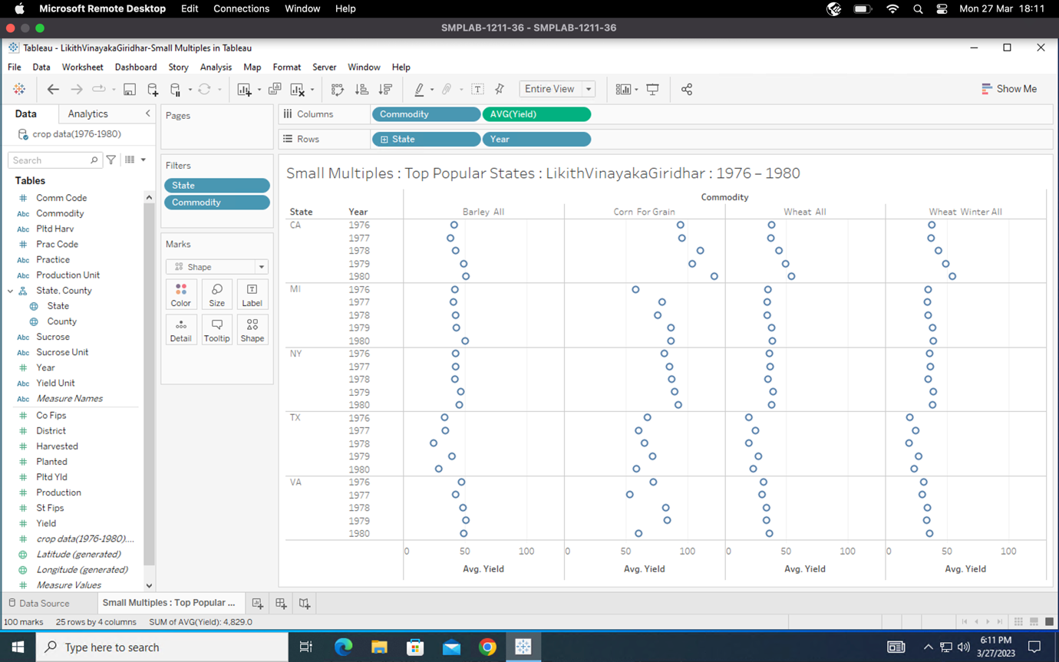

Q3)

Q4)

The top 5 counties of California from the visualization are:

* Placer
* D60 Sierra Mountains
* Yuba
* Butte
* Sutter

Q5)

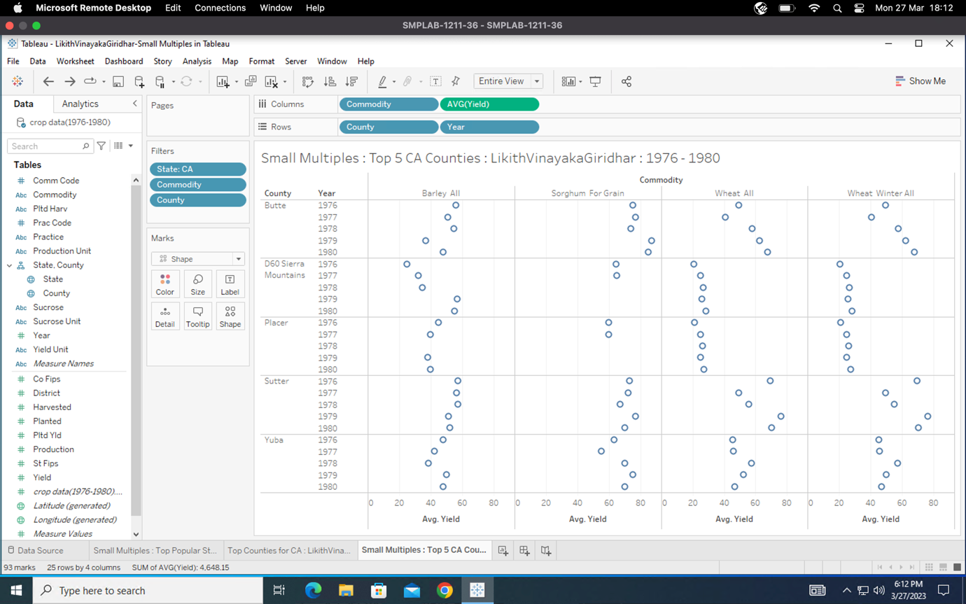

Q6)

* In between 1978 to 1980 we could say that Sorghum for Grain wasn’t grown in any of the top 5 counties in CA. or the data might be missing.
* In counties Sutter, “Barley All” and “Sorghum for Grain” has an average yield value in the range of 40-60. The range increases to 40-80 for “Wheat All” and “Wheat Winter All”.
* Comparing the various crops, on an average, we see that Sorghum For Grain was produced most in the top 5 counties in CA between 1976-1980.
* We can observe that Sutter produced maximum yield of Wheat All among the top 5 counties in CA between 1976-1980.
* Wheat All and Wheat Winter All has a similar yield pattern across all 5 counties between 1976-1980.

Q7)

The two commodities which have similar pattern change in average yield throughout all the 5 years for all the top 5 counties in California are Wheat All and Wheat Winter.

Q8)

Q9)

The **logical rhetoric** was utilized to examine each worksheet and extract valuable observations, such as the finding that Sorghum for Grain was the most produced crop among the top 5 counties in California during the period of 1976-1980. This approach is consistent with our visual representations and narrative because all of our illustrations and discoveries present reasonable and coherent arguments.